Chengeng Xiao

Student ID: 913186040

ECS30

Assigment 2 Linux

Professor Bishop

1: (*15 points*) Suppose I have a file named *x* in my home directory. File *y* is a (hard) link to this file, and file *z* is a symbolic link to it. I now type:

1, cat x: No such file or directory. Because x is no longer in the location

2,cat y: print the information in x. Because y is a hard link of x, can read x even the location is changed

3,cat z: No such file or directory. Because z is a symbolic link that links to the location that no longer saves x’s information.

No such file or directory

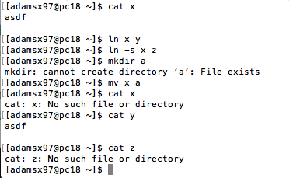

2, (*5 points*) Give a one-line Linux command that replaces every blank space with the letter ‘X’ in a file.

tr “ ” “x” < filename

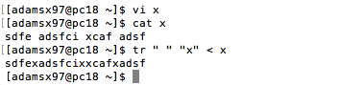

3, (*5 points*) Give a Linux command that prints the calendar for the month of September in 1752. What is unusual about that month?

The command is : cal 9 1752

There are some dates missing in the calendar.

